Q1 / Breast Ductal Papilloma
Stem:
Stem: 59y postmenopausal female presenting with complaints of unilateral bloody nipple discharge from the right breast. Mammogram is unremarkable.

What is most likely diagnosis?
Intraductal papilloma
What would you like to do now?
- Ultrasound vs MRI vs contrast ductography: US demonstrated a dilated duct in the right periareolar area
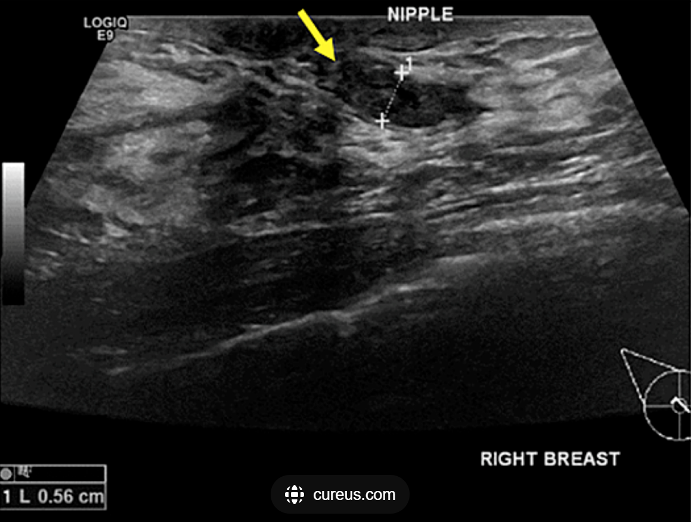
2. Ultrasound guided biopsy: indeterminate
3. OR:
Describe:
- Terminal duct excision/excisional biopsy
- Insert a fine lacrimal duct probe into the dilated duct.
- Make a periareolar incision (no more than 30% circumference
- Isolate the affected duct
- Resect the subareolar region with the abnormal duct attempting to preserve unaffected duct(s) if possible.
4. Pathology: Confirming.

Q2 / ICU Scenario
Septic Shock / PEA Arrest — ICU Scenario
Stem: A 66-year-old female, POD3 from an open low anterior resection for rectal cancer. She was transferred earlier to SICU for tachycardia , CT C/A/P ordered earlier but pending, You are called to see her for a change in clinical status
The nurse reports:
“Her pressure is dropping, she looks awful.”
Vitals on arrival:
- HR 122
- BP 74/38
- RR 28
- Temp 39.6°C
- SpO₂ 92% on 3L NC
- UOP for last 2 hours: 5 mL
She is lethargic, What do you do?

- ABCs
- Ensure large-bore IV ×2
- Fluid resuscitation (30 mL/kg)
- Labs: CBC, CMP, lactate, cultures ×2
- Broad-spectrum antibiotics immediately
- Assess for source (wound, drains, Foley, abdomen, lungs)
What is your most likely diagnosis?
- Septic shock
After 30 mL/kg fluids:
- BP remains 78/40
- HR 130
- Lactate returns: 6.8
What next?
- Start pressors / norepinephrine
- Reassess volume status
- Add vasopressin if needed
- Arterial line
- CXR / Abdominal Xray : No free air, but can’t rule out due to supine position
- FAST : Inconclusive
Now you are able to maintain MAPs > 60
- STAT CT scan to evaluate for intra-abdominal source
CT Scan Returns:
- Large pelvic fluid collection, gas-containing, adjacent to anastomosis
Next step?
- IR consult for drainage Or
- If unstablize → OR for washout + diversion (Hartmann’s)
You call IR, they call for the patient and before they move the patient, the nurse calls you back immediately, patient is crashing,
Monitor shows:
- HR 30 → then flat line
- BP unmeasurable
- No pulse
- Rhythm on monitor is organized but without a pulse
What is this?
PEA arrest
What do you do RIGHT NOW?
(Resident must go straight into ACLS — no hesitation.)
- Start high-quality CPR immediately.
- bag-mask oxygenation.
- Give epinephrine 1 mg IV every 3–5 minutes.
- Identify Reversible Causes (H’s and T’s)
Expected in septic shock PEA:
- Hypovolemia
- Hypoxia
- Acidosis
- Hyperkalemia
- Thrombosis
- Tamponade
- Tension pneumothorax
- Toxins
After 2 rounds of CPR + epinephrine: ROSC achieved.
Vitals:
- HR 128
- BP 82/46 on norepinephrine + vasopressin
- Still altered
- Lactate climbing
- Still febrile
What do you do next?
- Secure airway (intubate)
- Aggressive resuscitation
- Continue vasopressors
- Urgent source control → OR for washout , stool diversion
- Broad-spectrum antibiotics
- Correct acidosis/hyperkalemia if present
Q3 / Sarcoma
Stem:
A 55-year-old male presents to your office after being referred from his PCP for further valuation of an asymptomatic mass on his right inner thigh.

PMH: None. Family history is noncontributory.

PE: There is poorly defined posterior right thigh mass, approximately 8 cm in diameter (specify compartment, posteromedial in this case based on picture, involving the hamstrings)

Labs: Not significant.

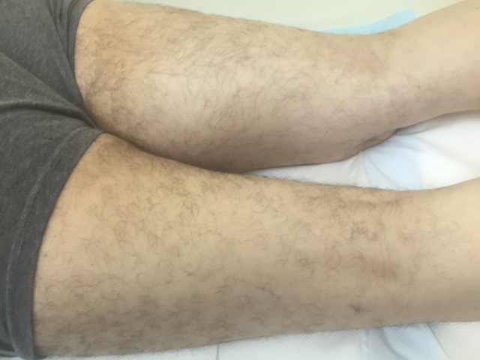
Describe how you would work up and manage this mass?
1. Plain radiograph of the thigh: Soft tissue mass with fat density (Need to start with plain radiograph to r/o periosteal or bone involvement)
2. MRI of the entire muscle compartment: soft tissue mass, with low signal intensity on T1 and high signal intensity on T2
3. Obtain image-guided core needle biopsy with multiple passes of 18g needle with site incorporated into possible resection margin → pathology: high grade pleomorphic sarcoma
4. Staging workup: CT of chest
What if the core needle biopsy came back as non-conclusive? -à Obtain incisional biopsy -à describe Technique. -à Along the axis and don’t develop fascial planes.
Mass is high grade; how would you approach this mass from an operative standpoint?
Radiate first
1. limb salvage.
2. Excision outside the pseudocapsule.
3. Radical resection of the muscle compartment Preserve sciatic
When is amputation indicated?
- Inability to resect without amputation
- Nonfunctional limb
A 32-year-old man with a history of FAP presents with a 15-cm firm mass in the right axilla that restricts his range of motion. A CNB confirms a desmoid tumor, imaging doesn’t show nerve involvement, patient requests excision, how would you council them regarding risk of recurrence. ?
- >50% chance of recurrence even with R0 resection
What if the mass was asymptomatic?
a. Observe.
b. Consider medical management with sulindac or other NSAIDs or tamoxifen.
What if this was a 32-year-old female and the mass was discovered during
pregnancy?
a. Post-partum give sulindac or tamoxifen or observe.

